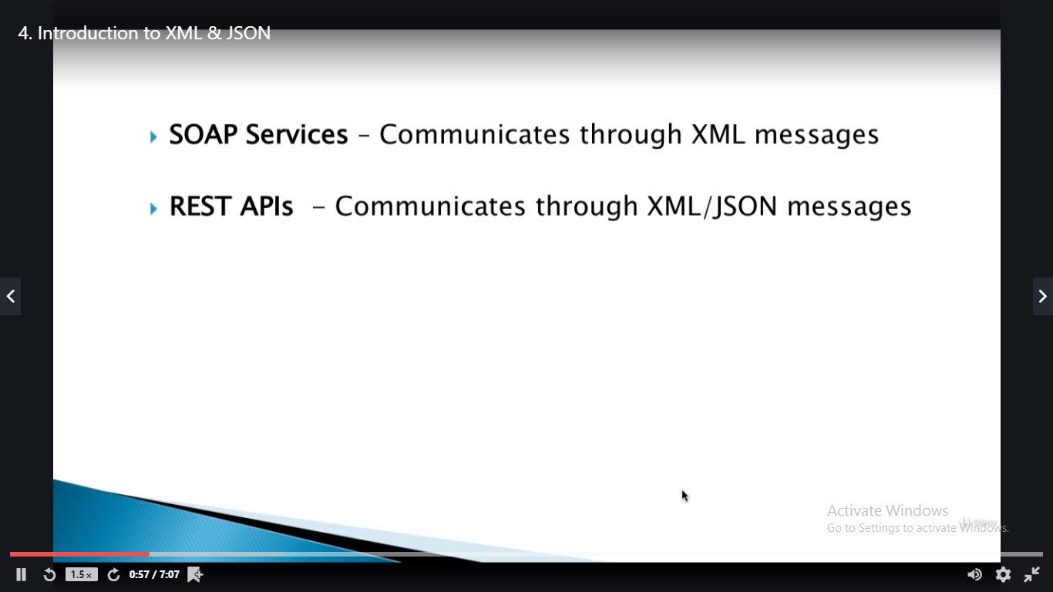

* As a tester we need to understand what kind of response we are getting and based on that we will write our Assertions.
* If it is xml messages we use xpath and for json messages we use Jsonpath assertions.

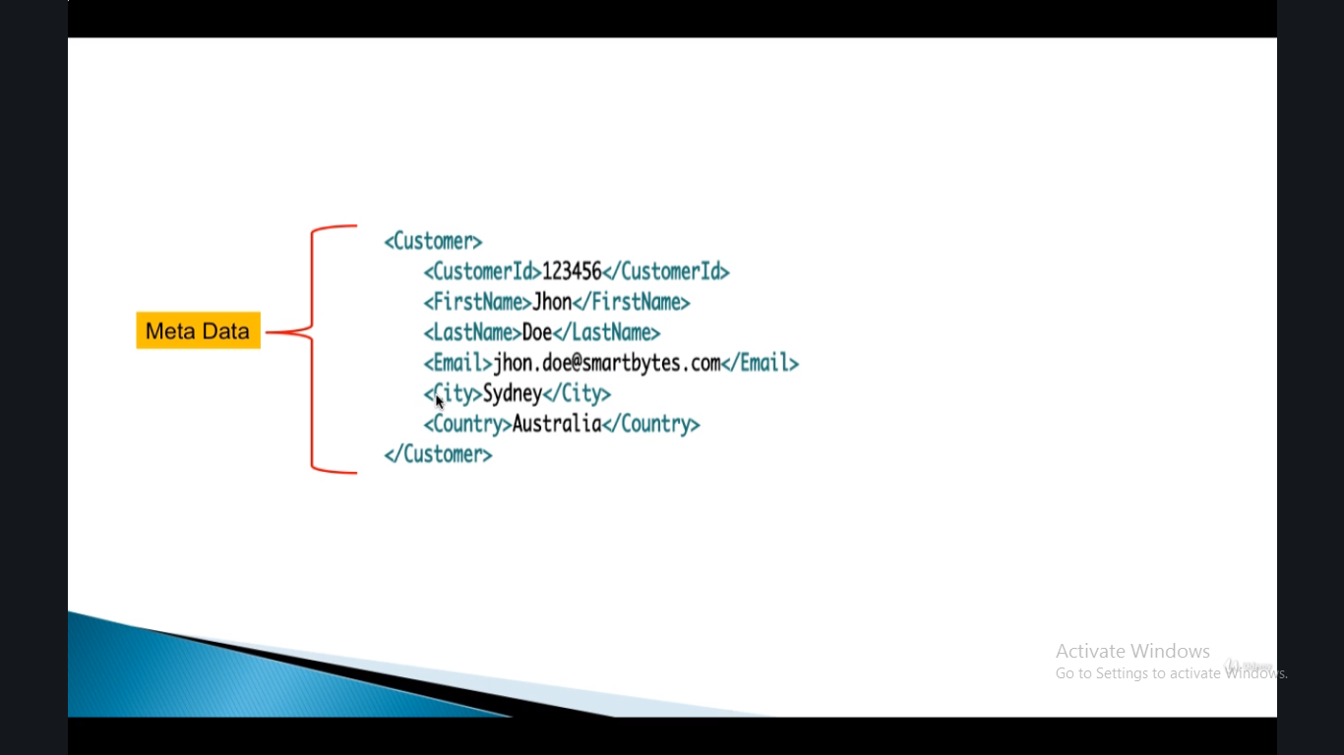

* Xml: extensible mark up language
* Json

